A Project Phase Capstone
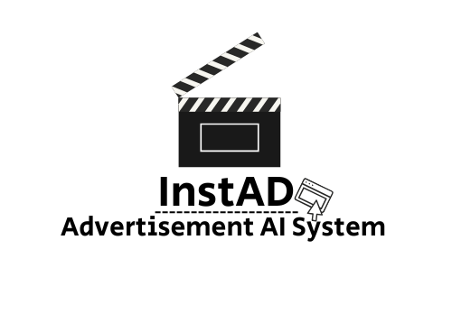

Supervisor:
Zakharia Frenkel
zfrenkel@braude.ac.il

Daniel Ayash Maor Siboni
daniayash96@gmail.com awesomemaor@gmail.com

Github rep link: awesomemaor/AI-Powered-Automatic-Advertisement-Generation-System: AI-Powered-Automatic-Advertisement-Generation-System

Table of Contents
Abstract 3
Introduction .1 3
1.2 Existing Solutions 4
1.3 Proposed Solution 5
1.4 Stakeholders and benefits 6
1.5 Document Structure 6
2. Related Work 7
7
2.1 Current methods and algorithms for AI-Based Advertisement Generation 7
2.2 Existing Tools for AI-Based Advertisement Generation 8
2.3 The Need and importance of AI-Powered Advertisement Tools 9
11
3. Expected Achievements 11
3.1 System Features and Functionalities 11
3.2 Algorithmic Logic and System Behavior 12
3.3 Success Criteria 14
16
4. Engineering Process – Development Methodology and Rationale 16
4.1 PART 1: PROCESS 16
4.1.1 Completed Tasks – What We’ve Done and How 18
4.1.3 In Progress – What We Are Building Now 19
4.1.4 Rationale Behind the Development Approach 20
4.1.5 Constraints and Challenges 22
4.2 PART 2: PRODUCT 24
4.2.1 Algorithms and AI Models 24
4.2.2 Data Structures 26
4.2.3 User Interface – Design & Flow 27
4.2.4 System Architecture & Diagrams 30
32
5. Testing Plan 32
5.1 Testing Strategy 32
5.2 Assumptions and Constraints 34
5.3 Testing Environment 34
6.Use of AI Tools 35
7. Sources: 36

Abstract
With the increasing demand for personalized marketing, artificial intelligence has become a central tool in automating ad creation. However, current AI-based advertising platforms often rely on rigid templates, technical input, or costly services—limiting access for small businesses and non-technical users. Prior research highlights the potential of generative AI in text, image, and video content creation, but also points to gaps in usability and personalization.
This project addresses those limitations by developing InstaAd, a desktop application that enables users to generate complete, personalized advertisements using only natural language input. The system integrates external AI APIs for script writing, image generation, and video synthesis, all coordinated through a modular backend and intuitive GUI. It also includes user authentication, ad history tracking, and a lightweight recommendation engine that adapts to user preferences over time.
By lowering the technical barrier and supporting flexible, end-to-end ad creation, InstaAd demonstrates how generative AI can be applied to make digital advertising more accessible, scalable, and user centered.

Introduction .1

1.1 Background and Problem Statement
The growing intersection between artificial intelligence (AI) and digital marketing has transformed the way advertisements are conceptualized and produced. With the explosion of data and demand for personalized content, traditional manual methods of ad creation are no longer sufficient. AI-powered tools have emerged as powerful alternatives, enabling the automated generation of marketing content tailored to specific audiences at scale.
At the heart of AI-driven advertisement generation lie several core algorithmic techniques. One of the most influential is the use of Natural Language Processing (NLP) models—especially transformer-based architectures like OpenAI's GPT or Google’s T5—which are capable of understanding user intent, rewriting ad copy, and aligning messaging with a brand’s voice.[5] These models analyze large corpora of marketing texts to learn patterns that resonate with audiences and produce persuasive, context-aware content.
In the visual domain, Generative Adversarial Networks (GANs) have revolutionized how images and videos are created.[1] GANs operate using two neural networks—a generator and a discriminator—that work in tandem to produce highly realistic visual content. These models are increasingly used in generating product visuals, background imagery, and dynamic video elements that align with campaign aesthetics. [8]
Additionally, reinforcement learning is often employed to optimize content based on performance metrics such as click-through rate (CTR) or conversion rates. By simulating user interaction, these systems learn which ad variants yield better engagement and adapt future generations accordingly.[1] [8]
While major platforms such as Google Ads and Meta Ads use such technologies to automate parts of the ad creation process, these systems are often rigid, expensive, or tailored for large businesses. They typically require substantial user input or technical expertise, creating a barrier for smaller businesses and individuals.
This growing gap highlights the need for accessible, intuitive AI-based advertisement tools that democratize content creation—allowing users without technical backgrounds to generate visually and contextually coherent ads swiftly and effectively.

1.2 Existing Solutions
In today’s digital landscape, tools providing Personalized Sales & Outreach capabilities leverage advanced AI technologies to create customized advertisements for individual clients or prospects. These tools not only reduce the cost of content creation but also enable businesses to deliver highly targeted ads that maintain a personal touch, strengthening relationships with customers. These platforms, which utilize ad-generation APIs such as Tavus, AdCreative.ai, and others, offer various capabilities for creating personalized video ads and customized messaging, some of the existing applications are:
SendSpark: This platform allows users to create personalized video messages as part of sales outreach and marketing campaigns. By utilizing the Tavus API, SendSpark enables the generation of videos where personalized content, such as a recipient's name, company logo, or custom script, is integrated into dynamic videos, offering a human-like approach to digital outreach.
Hippo Video: An all-in-one video creation and marketing tool, Hippo Video makes use of AI to generate customized video content at scale. Its integration with APIs like Tavus facilitates the rapid production of personalized video ads tailored to each viewer, improving engagement for sales teams and marketers.
BHuman: Specializing in video outreach and personalized marketing, BHuman utilizes AI video generation to create custom video messages quickly and efficiently. Their integration with AI-powered ad generation tools allows for large-scale campaigns that feel personalized and human-centered.
These solutions illustrate the growing use of AI-driven technologies to scale the creation of personalized ads and outreach videos. Although these tools make significant strides in efficiency and personalization, the limitations in creative flexibility, customization options, and user accessibility remain challenges that our solution aims to address.

1.3 Proposed Solution
Our proposed project introduces an AI-powered system designed to automatically generate personalized advertisements through a streamlined, user-friendly interface. Unlike existing platforms such as SendSpark, Hippo Video, or BHuman, which require structured input, predefined templates, or video editing skills, our system enables users to create engaging ads simply by entering a short textual prompt in natural language.
The core advantage of our solution lies in its simplicity, accessibility, and creative flexibility. While other platforms often rely on pre-made templates and user-defined parameters, our system uses advanced generative AI models—including large language models (LLMs) for script generation, text-to-image and text-to-video algorithms for visual output, and voice synthesis APIs—to fully automate the ad creation process. This allows for truly unlimited creativity, as the AI constructs the advertisement end-to-end without the need for human intervention at each stage.
Another key feature is ease of use. The application is designed for non-technical users and small business owners who may not have experience with marketing or design tools. By abstracting the complexity of ad generation, users can create professional, customized video ads with just a few clicks—no editing, no templates, and no technical knowledge required.
Furthermore, the system integrates a learning component, which tracks previous user preferences and content types to offer personalized ad suggestions over time. This makes the tool smarter and more relevant with continued use, unlike other solutions that offer static or one-time outputs.

1.4 Stakeholders and benefits
The primary stakeholders who will benefit from this solution include:
- Small and Medium-Sized Enterprises (SMEs): These businesses often lack the budget or personnel to produce professional ads. Our system allows them to generate quality content quickly and independently, without needing to hire designers or marketers.
- Independent Creators and Entrepreneurs: Individuals who promote personal brands, products, or services can easily create engaging ads that match their vision and messaging, without relying on external tools or expertise.
- Marketers and Social Media Managers: Professionals managing multiple campaigns can use the system to speed up their content creation process and test multiple ad variations in real time.
- Content Platforms and Agencies: Platforms or services offering digital tools can integrate our solution via API to enrich their own offerings with automated ad generation capabilities.
By offering an accessible, automated, and personalized ad creation experience, the system empowers users to maintain creative control, reduce costs, and respond to market needs with speed and agility.

1.5 Document Structure
Chapter 1: Introduction
Presents the background, objectives, and motivation for the project.
Chapter 2: Requirements Analysis
Describes the functional and non-functional requirements of the system.
Chapter 3: System Design and Architecture
Provides an overview of the system’s high-level architecture, including package and activity diagrams.
Chapter 4: Engineering Process
Details the development methodology, tools used, design rationale, and implementation status.
Chapter 5: Testing Plan
Describes the testing strategy, environment, assumptions, and evaluation approach.
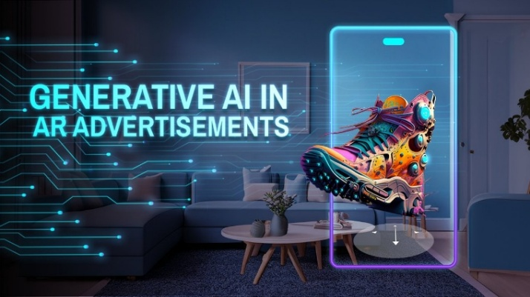

2. Related Work

2.1 Current methods and algorithms for AI-Based Advertisement Generation
The rise of Generative AI (GenAI) has significantly transformed the landscape of digital advertising. Unlike traditional AI, which primarily focuses on data analysis, automation, and decision-making, generative AI actively creates original content—text, images, video, and audio—through deep learning and advanced neural networks such as GANs (Generative Adversarial Networks), Transformers, and Autoencoders.
A) Common Workflow: From Prompt to Ad
When a user wants to generate an advertisement using AI, the typical workflow includes: [7]
1. User Input (Prompt): The user provides a short textual description of the desired ad, such as product details, brand tone, and target audience.
2. Natural Language Understanding (NLU): The system processes the input using models like BERT or GPT to understand intent, emotion, and key marketing terms.
3. Text generation: Leveraging language models (e.g., GPT-4), the system generates ad copy or script based on user intent.
4. Image generation: Tools like DALL-E, Midjourney, or Stable Diffusion produce visual assets from text prompts.
5. Video synthesis: Advanced systems use GANs or diffusion models to render short ads, often based on prior visual patterns or templates.
B) Underlying Technologies and Algorithms
Generative Adversarial Networks (GANs)
GANs consist of two neural networks: a generator and a discriminator, trained together in a feedback loop. The generator tries to produce realistic ad content (images/videos), while the discriminator attempts to differentiate between real and synthetic content. This technique is widely used for visual ad creation.
Transformers and Large Language Models (LLMs)
Transformers power text generation in tools like ChatGPT and Jasper. These models are pre-trained on massive datasets and fine-tuned for tasks such as marketing language creation, emotional tone detection, and persuasive copywriting.
Programmatic Advertising
AI automates media buying and campaign delivery by analyzing user profiles and purchasing behavior. Programmatic platforms use algorithms to decide:
Who sees the ad, when they see it, where it's placed.
Tools like Google Ads and Facebook Ads use ML models trained on historical performance data to optimize ad spending and conversion rates. [2][3][1][7]

2.2 Existing Tools for AI-Based Advertisement Generation
The integration of Artificial Intelligence (AI) into advertisement creation has led to the development of various tools aimed at automating and streamlining the process. Notable examples include:
- AdCreative.ai: This platform utilizes machine learning algorithms to generate multiple ad variations based on user inputs such as logos, brand colors, and textual content. The system predicts the performance of each creative, allowing marketers to select the most effective ones. Additionally, it offers seamless integration with major advertising platforms, facilitating direct deployment of ads.
- Predis.ai: Predis.ai employs AI to automate the creation of ad copies, social media posts, and other creative assets. By analyzing user inputs and adhering to brand guidelines, it generates customized content optimized for high conversion rates. The platform supports multiple languages and offers a vast library of multimedia and template options.
- AdGen AI: AdGen AI streamlines ad creation by analyzing a user's website URL to extract brand-specific styles and messaging. It then generates over 100 ad variations tailored for platforms like Meta Ads and Google Ads. This approach significantly reduces the time and effort required for ad development.
- QuickAds.ai: QuickAds.ai offers a comprehensive solution for creating image and video ads swiftly. Its algorithms detect consumer behavior patterns, predict optimal targeting spots, and boost conversion rates. The platform supports over 15 ad formats, ensuring compatibility across various platforms such as Facebook, Instagram, and TikTok.
A) Limitations of Current Solutions
Despite the advancements in AI-driven ad generation, existing tools exhibit several limitations:
- Complexity in User Interaction: Many platforms require users to navigate through multiple steps, including selecting templates, adjusting designs, and inputting detailed information. This complexity can be a barrier for users without technical expertise.
- Limited Creative Flexibility: The reliance on predefined templates restricts the uniqueness of the generated ads, potentially leading to repetitive or generic content.
- Lack of Personalization and Memory: Current tools often do not retain information about previous user interactions or preferences, limiting their ability to produce personalized content based on historical data. [1]
B) The Need for Enhanced AI Advertisement Solutions
The evolving digital marketing landscape necessitates AI tools that are more accessible, intuitive, and capable of producing personalized content. Key requirements include:
- Natural Language Interaction: Allowing users to generate ads through simple text prompts can democratize ad creation, making it accessible to individuals without technical backgrounds.
- Integrated Memory for Personalization: Incorporating memory mechanisms enables AI systems to learn from previous interactions, facilitating the creation of more tailored and contextually relevant ads.
- Simplified User Experience: Reducing the complexity of the ad creation process by minimizing the need for manual adjustments and template selections can enhance user engagement and efficiency.
Addressing these needs can significantly improve the effectiveness and accessibility of AI-driven advertisement generation tools, particularly for small businesses and individual users. [7]

2.3 The Need for and importance of AI-Powered Advertisement Tools
The growing dependence on digital media has intensified the need for constant content generation across multiple platforms, making AI content generators vital tools for modern creators and businesses. One of the most significant benefits of AI content generators is their ability to save time and increase productivity. Manually crafting SEO optimized headlines, blog posts, social media updates, and videos can be a tedious and repetitive process. AI automates these tasks, allowing creators to focus on more critical aspects of their projects, such as strategy, creativity and engagement. By handling time-consuming details, AI content generators free up valuable time for creators and help them deliver consistent, high-quality content faster. In addition to saving time, AI content generators offer improved content optimization. These tools use advanced algorithms to analyze data trends, keyword relevance and SEO strategies, ensuring that every piece of content is optimized for search engines and audience engagement. For businesses, this means their content has a better chance of ranking higher in search results, reaching their intended audience and increasing traffic. Whether it’s designing effective hashtags for social media posts, creating compelling blog titles, or improving the readability of articles, AI-driven tools ensure that content is optimized to meet the demands of a specific platform.
Another critical importance of AI content generators is their ability to personalize content based on the needs of different target groups. Content creation isn’t a one-size-fits- all approach, and AI makes it possible to tailor output to match specific audience interests, demographics or industry trends. For example, AI tools can tailor blog posts, emails or social media headlines to better resonate with the intended reader, increasing the likelihood of engagement and conversion. This level of personalization is invaluable for marketers and businesses looking to build strong relationships with their audiences and deliver relevant and meaningful content. Finally, AI content generators are a cost-effective solution for businesses and creators with limited resources. Hiring a large team to manage content across multiple platforms can be expensive and time-consuming. AI tools provide an affordable alternative and perform tasks that would normally require more experts, such as writers, SEO experts and social media managers. For startups, small businesses or individual creators, this means they can produce high-quality, competitive content without breaking the bank, leveling the playing field with larger competitors. AI content generators allow creators to scale their efforts while keeping costs low and results high. [4] [7] [8]
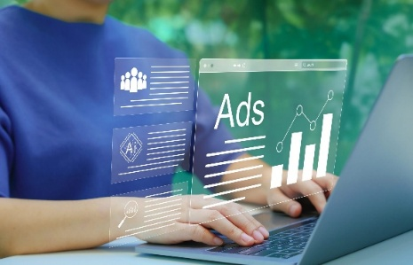

3. Expected Achievements

Our project aims to develop a user-friendly desktop gui application that allows users to generate personalized advertisements using artificial intelligence via external APIs. The platform is designed to be simple, intuitive, and accessible to users without technical or design knowledge. Below are the specific components and expected deliverables that will be developed as part of the project.

3.1 System Features and Functionalities

a. Welcome Screen
- A simple welcome interface displaying the message “Welcome to InstaAd.”
- Two buttons: Login and Register.

b. Login Screen
- User authentication using username and password.
- A Back button to return to the welcome screen.

c. Registration Screen
- Fields to enter username, password, confirm password, and email.
- An additional dropdown or selection field to specify the type of business/brand the user represents.
- A Back button to return to the welcome screen.

d. User Home Screen (Dashboard)
- Personalized greeting: “Welcome, [username]”.
- A Logout button available on all screens post-login.
- Three main action buttons:
Generate Advertisement
  - Opens a screen with a text field where the user can enter a prompt in natural language.
  - The backend processes the prompt and selects the appropriate AI API (e.g., OpenAI for text, DALL·E for image) to generate a full advertisement.
  - The result is displayed in a new screen, as a text, image, or link to generated media.
  - The screen includes options to:
    - Save the advertisement to the user’s personal history.
    - Edit and regenerate the advertisement with a new prompt.
    - Back to return to the dashboard.
    - Display a Loading screen while the ad is being generated.
Advertisement History
  - Displays a list of previously saved advertisements for the logged-in user.
  - Each saved ad can be viewed or deleted.
Generate Recommended Advertisement
  - Uses AI (e.g., NLP-based recommendation engine) to analyze the user’s previous ads and generate a random yet relevant ad suggestion based on past behavior and content.
  - The user can save or regenerate another random ad.
  - Intended to support inspiration and quick marketing ideas based on personal history.

3.2 Algorithmic Logic and System Behavior
The software logic includes the following main flows:

a. Authentication Flow
- Login:
  - The user inputs credentials → The backend validates the username/password against the MongoDB database.
- Registration:
  - Form input is validated on the client side and backend.
  - Upon success, a new user is created and saved in the user's collection in MongoDB.

b. AI-Based Advertisement Generation
Once a user submits a natural language prompt (e.g., “Create an exciting summer campaign for a new beverage”), the system triggers a multi-step process that dynamically selects and interacts with various AI APIs, depending on the content type required. The workflow includes:
- Text Generation
The system routes the prompt to a text-generation API capable of producing creative and persuasive advertising copy. This API returns a structured message (e.g., headline, slogan, body text) suited to the intended audience and tone.
- Image Generation
If the prompt requires visual elements, it is sent to an image-generation API that converts textual input into a high-resolution branded image. This may include product renders, thematic graphics, or styled marketing visuals.
- Video Generation
For full multimedia ads, the system can forward a combination of text, images, and/or audio to a video-generation API. This API may construct a short promotional video by combining transitions, animations, voiceovers, and branded visuals.
- Audio Generation
If the user wants to add a voice, the ad copy is forwarded to a text-to-speech API. This component transforms the written script into a lifelike voice narration, potentially with support for tone, language, and gender customization.

Once all requested components are generated, the backend compiles the results and sends them to the frontend, where the user can view, save, or edit the adversitment.

c. Recommendation Flow
- When the user chooses “Generate Recommended Ad”, the system uses past prompt history to:
  - Identify patterns in brand type or tone
  - Suggest a new prompt or ad idea using a basic recommendation engine (e.g., keyword matching or prompt embedding similarity)
- The suggested prompt is then passed through the same generation flow.

d. History Management
- Every saved ad is stored in MongoDB linked to the user’s account.
- Ads are retrieved and displayed in the History screen with options to view or delete.

3.3 Success Criteria
The goal of this project is to develop an AI-powered desktop application that enables users to generate high-quality, personalized advertisements through a simple and intuitive interface. The following are the key achievements we aim to reach by the end of the project:
The project will be considered successful if it meets the following measurable goals:
- Users can successfully register, log in, and navigate between screens with a smooth and consistent experience.
- The system successfully generates a complete ad from a prompt.
- Recommended ads are successfully generated based on user history
- Backend logic handles API requests, responses, and errors gracefully
- Advertisement generation is completed within a reasonable time,
- Data, such as user inputs and ad history, is stored and retrieved reliably from the database, ensuring persistence across sessions.

Functional:
1
  The system will allow a new user to register by entering a username, email, password, and selecting a business type.
2 | The system will allow existing users to log in using a valid username and password
3 | The system will display a personalized dashboard with greeting and main options
4 | The system will let the user generate an ad (regular or recommended)
5
  The system will send the generation request to the backend for processing via external AI APIs.
6 | The system shall receive and display a generated advertisement that includes text and visual (image or video).
7 | The system shall allow the user to save the generated advertisement to their personal history.
8 | The system will allow the user to regenerate/edit the advertisement.
9 | The system will save all the data in a stored database collection
10 | The system will provide a graphical user interface (GUI) that allows users to navigate between screens and perform all core actions.
Non-Functional:
1 | The user will login/register successfully.
2 | User data will be stored in a database.
3 | Login credentials will be authenticated.
4
  The graphical user interface (GUI) will be accessible, intuitive, clear and usable by non-technical users.
5 | The user will use natural language prompt to generate an advertisement
6 | Prompt history will be saved automatically and used for improving recommendations
7 | The user can save advertisements successfully.
8 | The advertisements will be saved in the database.
9 | Generated advertisement will load within a reasonable time


4. Engineering Process – Development Methodology and Rationale

The engineering process of our project follows an iterative, modular, and API-driven approach, grounded in agile software development principles. This strategy enables flexibility, rapid prototyping, and ease of testing and integration. Below is a detailed breakdown of the phases we've completed so far and the next steps in the pipeline.

4.1 PART 1: PROCESS

Phase 1: Research and Requirement Analysis
In the initial phase, we conducted a comprehensive market and technology research to better understand the landscape of AI-powered advertisement tools. This involved:
- Comparative analysis of existing solutions like AdCreative.ai, SendSpark, and BHuman
- Identifying key pain points: most tools required either technical knowledge, worked via rigid templates, or lacked flexibility and personalization
- Defining our target users: non-technical individuals, entrepreneurs, and small businesses seeking accessible, fast, and creative ad generation tools
- Mapping functional and non-functional requirements:
  - Must-have: prompt-based ad generation, image + text output, user authentication
  - Optional: voice-over/video generation, recommendation engine
- Technology exploration: reviewing the capabilities and API documentation for:
  - OpenAI (for text generation)
  - DALL·E or similar (image generation)
  - MongoDB for user data
  - FastAPI for backend services
  - PyQt5 for GUI development
This phase helped us define a clear scope, a minimal viable product (MVP), and prioritize core features for implementation.

Phase 2: System Architecture and Design
After defining the requirements, we moved on to designing the system architecture. The architecture was planned as a three-tier modular structure:
- Frontend: Developed in Python using PyQt5, responsible for user interaction through a desktop GUI.
- Backend: Developed in FastAPI, acting as a lightweight server that handles:
  - User authentication
  - Communication with external AI APIs
  - Data management with MongoDB
- Database: A MongoDB cloud instance that stores:
  - User profiles (username, email, business type)
  - Login credentials (securely hashed)
  - Advertisement history per user
We also designed the data flow and separation of concerns:
- Frontend handles UI only, never stores data locally
- Backend handles all API logic and data processing
- MongoDB stores all persistent information (user data and ad history)
This structure enables scalability, security, and clear testing separation between UI, logic, and storage.

Phase 3: Core Implementation – Completed and Ongoing Tasks
This phase focused on building the functional backbone of the project: setting up user access, data storage, and interaction with core services. It involved both UI design and backend development using industry-standard technologies.

4.1.1 Completed Tasks – What We’ve Done and How
Initial GUI Prototype with PyQt5
We began the implementation by designing the GUI structure using PyQt5—a mature Python library for building cross-platform desktop applications. This helped us visualize and plan user flows early on.
- Created a working prototype with navigation logic between screens using stacked widgets
- Implemented the basic layout for the Welcome screen, Login, Register, and placeholder for the Dashboard
- This step helped us define the user experience (UX): what actions users will perform and how the interface should guide them
Motivation: We prioritized GUI prototyping first to solidify UX early, ensuring our app is intuitive and beginner-friendly before integrating backend logic.

Login and Registration Functionality
Once the screens were in place, we implemented user authentication logic. The process included:
- Designing input validation rules (non-empty, password matching, email format)
- Creating backend routes (/register, /login) using FastAPI, a modern and high-performance web framework for Python
- Setting up a MongoDB database, where:
  - Each registered user is saved with their username, hashed password, email, and selected business type
  - Authentication data is retrieved securely during login
We successfully integrated this flow so that:
- Users can register once and are stored persistently
- On login, the system checks credentials and grants access to the dashboard
Security Consideration: Passwords are hashed before being stored, and only validated using secure hash comparison.

Backend Setup with FastAPI + MongoDB Integration
We built a backend server using FastAPI, which currently handles:
- Authentication logic (/register, /login)
- Connection to the MongoDB Atlas cluster via pymongo
- Serving responses to the frontend in JSON format
- Designed endpoints to be easily extendable (e.g., for ad generation and history management)

4.1.3 In Progress – What We Are Building Now
Main Functionality – Ad Generation from Prompt
This is the core engine of the system, allowing users to generate personalized advertisements by writing a simple sentence (prompt). Here's how it's being developed:
- Frontend:
  - User enters a natural language prompt (e.g., “Create a winter campaign for hot chocolate”)
  - Prompt is sent via a POST request to the FastAPI backend
- Backend Logic (Currently under construction):
  - Backend receives the prompt and analyzes its type (text/image/video) based on keywords or settings
  - Routes the request to the appropriate AI API:
    - OpenAI GPT for generating the ad copy (e.g., headline + slogan + description)
    - DALL·E or Stable Diffusion for generating a visual image
    - Optionally (planned), voice-over via text-to-speech (TTS)
  - Backend compiles the response (text + image link) and returns it to the frontend
- Next Steps:
  - Complete the API calling logic
  - Handle API responses (parse, format, and display in GUI)
  - Add error handling for failed API responses or empty prompts
  - Design the loading screen while the ad is being generated
Status: Communication between PyQt5 ↔ FastAPI is working. Next step is integrating external APIs and managing the response structure.

Recommended Ad Generation
This feature will allow the user to click "Generate Recommended Ad" and receive an auto-suggested idea based on past usage.
- Logic (Planned):
  - System will analyze past prompts (e.g., tone, topics, keywords)
  - Uses either:
    - Prompt similarity via NLP embeddings (e.g., sentence-transformers)
    - Rule-based mapping (e.g., if user often enters "food" → suggest seasonal menu ads)
- Implementation Plan:
  - Add a new FastAPI endpoint /recommend
  - On request, backend will:
    - Fetch user’s history from MongoDB
    - Analyze patterns and select/create a new prompt
    - Return it to frontend for optional editing or direct generation
Goal: Reduce user effort and offer creative inspiration based on historical usage.

Advertisement History Management
Storing and displaying the ads a user has created is a key usability feature.
- Backend:
  - After an ad is generated, a structured record (prompt, result text, image link, timestamp) will be saved under the user’s profile in MongoDB
- Frontend:
  - A new screen called “My Ads” or “History” will:
    - Fetch this list
    - Display each saved ad with an option to view or delete
    - Possibly add a button to regenerate a similar ad
Status: MongoDB structure for storing ads is planned. Routes and frontend UI are under development.

4.1.4 Rationale Behind the Development Approach
Throughout the planning and development of our system, we made several strategic decisions to ensure the project would be scalable, maintainable, and user-friendly. Below is a breakdown of the key guiding principles that shaped our engineering methodology:

Start with User Access and Flow
Before implementing any AI functionality, we focused on building the user management system—including registration, login, and profile handling.
- Why?
A personalized system requires a reliable way to identify and differentiate between users. Since features like ad history, recommendations, and usage tracking depend on user identity, setting up secure authentication early was critical.
- Result:
This allowed us to build a solid foundation for all future personalized features while enabling persistent storage of user-generated content.

Build Modularly
We adopted a modular design strategy, dividing the system into three loosely coupled layers:
- The Frontend (PyQt5) – handles the GUI and user input
- The Backend (FastAPI) – processes logic, APIs, and data
- The Database (MongoDB) – stores persistent user data and ad history
- Why?
This approach improves code clarity, simplifies testing, and allows each component to be developed, debugged, or replaced independently. For example, we could swap out one AI API without needing to change the GUI logic.
- Benefit:
Increased flexibility and easier parallel development across the team.

Use Proven Tools
We chose PyQt5, FastAPI, and MongoDB based on their maturity, community support, and development speed.
- PyQt5: A stable and feature-rich GUI framework that supports cross-platform desktop applications.
- FastAPI: A fast, modern Python framework ideal for asynchronous API handling and clean RESTful architecture.
- MongoDB: A scalable NoSQL database that fits perfectly with our document-based data needs.
- Why?
These technologies allowed us to move quickly and focus on building our features rather than wrestling with low-level bugs or infrastructure.

Secure and Scalable Data Handling
We used MongoDB to store user accounts, prompt history, and generated ads in a flexible, schema-free structure.
- Why?
  - MongoDB’s document-based model allows us to easily store complex ad data (text, image links, timestamps) under each user.
  - It is scalable, making it suitable for both small testing phases and future real-world usage.
  - Built-in support for indexing and querying improves performance as the database grows.
- Security Measures:
  - User passwords are hashed before storage.
  - The backend only accepts validated and sanitized input.
By following this approach, we ensured our development process is not only efficient but also future-ready. As new features are added—such as ad recommendations, multimedia generation, and analytics—they can be plugged into the existing system with minimal disruption.

4.1.5 Constraints and Challenges
Despite the advantages of using modern AI technologies and modular architecture, our development process is shaped by several constraints—both technical and strategic. Below are the main challenges we've encountered or expect to encounter as we continue to build the system:
API Limitations & Costs
Our system depends on third-party AI APIs (e.g., OpenAI’s GPT for text, DALL·E for image generation, and external TTS services for voice synthesis). These APIs come with:
- Usage limits: Many APIs have strict rate limits (e.g., number of requests per minute or per day), which restrict the number of ads we can generate within a short period.
- Monetary cost: API usage is often billed per token, image, or character. This becomes costly, especially if the system scales or users make repeated ad generation requests.
Implication:
We must manage API usage efficiently, possibly by:
- Caching previously generated results when relevant
- Monitoring and limiting usage per user session
- Offering premium features if needed in the future
Latency in AI Responses
Some AI processes, especially those involving image rendering, video synthesis, or text-to-speech, introduce non-negligible response times (ranging from 2 to 30 seconds or more).
- Text generation (GPT) is relatively fast
- Image generation (DALL·E, Stable Diffusion) can take several seconds, especially for high-resolution output
- Voice or video synthesis can take even longer depending on media length and complexity
Implication:
This affects the user experience, making it feel slow or unresponsive if not handled properly.
Mitigation:
We plan to:
- Display a loading screen or animation while results are generated
- Notify users of estimated wait times
- Perform some operations asynchronously (if architecture permits)

User Interface Design Tradeoffs
Our target users are mostly non-technical individuals, so the UI must be intuitive. However, we also want to provide enough control over generated content (e.g., ability to rephrase, regenerate, or slightly customize ads).
This creates a UI/UX dilemma:
- Too simple = not flexible enough for real use
- Too complex = overwhelming for first-time users
Implication:
We must find a balance between automation and customization, such as:
- Letting users regenerate ads with a single click
- Allowing optional editing of prompts or results
- Presenting advanced options only when needed (progressive disclosure)
4. Security and Data Privacy

Since our system stores user-specific data—including login credentials, email, business preferences, and advertising history—we must ensure secure handling of sensitive information.
Challenges include:
- Authentication security: Preventing unauthorized access to accounts
- Data protection: Ensuring stored ads and prompts cannot be accessed by other users
- Database security: Protecting MongoDB access via authentication and network rules
- Input sanitization: Preventing malicious prompt injection or abuse of API endpoints
Mitigation steps taken:
- Passwords are securely hashed before being stored
- Access to MongoDB is protected by user-level permissions
- FastAPI routes validate and sanitize user input before processing

To sum up,
These challenges are an inherent part of building a real-world, AI-integrated application. Addressing them effectively helps us:
- Deliver a smoother user experience
- Manage costs for sustainable operation
- Protect user trust through secure and ethical development
Each constraint has shaped our engineering decisions—from architectural design to interface simplicity—and continues to guide our planning for future improvements.

4.2 PART 2: PRODUCT

4.2.1 Algorithms and AI Models
Our system combines external AI capabilities with internally designed logic to deliver automated, high-quality advertisement generation. The algorithms we use are centered around four main processes: multimedia ad generation, user registration and login handling, and personalized ad recommendations.
Video Generation from Text and Static Image
The central functionality of our application is the ability to create short promotional videos using a text prompt and a pre-defined brand image.
When a user provides a short description of the desired advertisement, the system uses a language generation model (such as GPT) to create a script tailored to the brand’s tone and product. This script is then paired with a static branded image (such as an avatar or logo selected by the user or predefined in the system).
The combination of the image and the script is sent to a third-party video synthesis API, which generates a talking-head style video. The result is a coherent, personalized video ad where the visual character presents the message with synchronized voice and branding.
This approach ensures brand consistency, reduces generation complexity, and maintains a user-friendly experience without requiring video editing skills.

User Registration Logic
The registration logic ensures that each user account is unique and securely stored. When a user registers, the system checks whether the username or email already exists in the database. If the user is new, their details—including username, email, password (stored securely), and business type—are saved.
This information is used later for:
- Personalizing the interface (e.g., greeting by name)
- Tracking ad generation history
- Offering personalized suggestions
This logic enables the system to create a profile that evolves as the user interacts with it.
Login Verification Process
When a user attempts to log in, the system verifies the credentials by comparing the entered data with the stored records. If the credentials are correct, access is granted, and the user’s data (such as ad history and preferences) is retrieved from the database.
This allows each user to access their personalized workspace and ensures that their saved content and recommendations remain private and persistent.
Recommended Advertisement Generation
To support creativity and convenience, our system includes a basic recommendation engine that learns from the user’s activity over time.
Every time a user generates an ad, the system analyzes the prompt and extracts key themes or keywords (e.g., “fitness”, “fashion”, “coffee”, etc.). These keywords are saved in the user’s profile and tracked over time.
When the user requests a recommended ad, the system:
- Retrieves the most relevant or frequently used keywords
- Matches those to a set of predefined prompt templates or advertising angles
- Generates a new prompt suggestion that reflects the user’s interests
The user can then accept this prompt, modify it, or generate the ad directly. This mechanism helps users discover new campaign ideas aligned with their past preferences, while minimizing the creative effort required.

4.2.2 Data Structures
The system's data is stored using a document-oriented approach, leveraging MongoDB as the primary database. This structure was chosen for its flexibility, scalability, and ability to handle dynamic and nested data formats, which align with the evolving nature of user-generated content. MongoDB stores data in a dictionary-style (key-value) format, allowing us to embed structured content directly inside each user's profile.
Data is passed between the client (PyQt5) and server (FastAPI) in JSON format, enabling smooth communication and compatibility with external AI APIs.
Our data model is divided into three main areas: User Profiles, Advertisement Records, and Prompt History.
User Profiles
Each user who registers has a dedicated document in the database that contains all relevant personal and contextual information. This includes:
- Username and email – to uniquely identify each user and enable login.
- Business type – selected during registration to provide context for ad generation.
- Prompt history – stored as a list of text entries representing past ad prompts submitted by the user.
- Ad history – stored as a list of structured records, each representing a previously generated ad.
This structure enables the system to retrieve and personalize data efficiently for each session, while ensuring separation and organization of user-specific content.
Advertisement Records
Each time a user generates an advertisement, the system adds a structured entry to their ad history. An advertisement record includes:
- The original prompt submitted by the user
- The generated text content, such as a headline, slogan, and short script
- A visual reference, such as an image or avatar used in the ad
- A video link or media identifier, if a video was generated
These records are embedded directly in the user's profile document as a list of dictionary-style entries. This setup allows users to manage their own ad content, revisit older ads, or regenerate variations based on past work.
Prompt Keyword Tracking (for Recommendations)
To support the ad recommendation feature, the system extracts keywords from each submitted prompt. These keywords are:
- Saved alongside the prompt history within the user's document
- Analyzed and ranked based on frequency and recency
- Used to identify trends in the user’s advertising interests
This information helps the system generate tailored prompt suggestions when the user selects the “Generate Recommended Ad” option.

Session and Authentication Data
User session-related data is managed through secure server-side logic, using the JSON format for transmitting login and registration information. Although not stored inside the user document, session data is essential for ensuring proper login verification and persistent interaction during a user’s active session.

4.2.3 User Interface – Design & Flow
The user interface (UI) of the system is developed using PyQt5, a powerful Python framework for building interactive desktop applications. The UI is intentionally designed to be simple, intuitive, and user-friendly, especially for non-technical users such as small business owners and independent creators.
The interface is structured into a series of clearly defined screens, each supporting a specific function in the user journey. The design emphasizes clarity, minimal user input, and a seamless flow between steps.
Welcome Screen
Upon launching the application, users are greeted with a welcome screen featuring two main options:
- Login
- Register
This screen serves as the gateway to the platform and guides new or returning users to the appropriate path.
Registration Screen
New users can create an account through a simple registration form that includes:
- Username
- Email
- Password and confirm password
- Business type selection (from a predefined list)
The goal is to gather enough contextual information to personalize ad generation without overwhelming the user. Once completed, users are redirected to the main dashboard.
Login Screen
Returning users can log in using their registered credentials. Upon successful login, the user is authenticated and forwarded to the dashboard. The system validates the provided information with the backend and grants access only if credentials match existing records.
Dashboard (User Home Screen)
The dashboard acts as the central hub of the application. It includes:
- A personalized greeting (e.g., “Welcome, Sarah”)
- A Logout button (available at all times post-login)
- Three main action buttons:
  - Generate Advertisement
  - Advertisement History
  - Generate Recommended Ad
This layout keeps the interface focused and action-driven, guiding users toward the core functionalities with minimal distractions.
Generate Advertisement Screen
This screen enables the user to generate a new advertisement by entering a short natural language prompt. The user types in their idea (e.g., “Create an ad for a weekend sale on handmade candles”) and clicks a button to generate.
While the AI processes the request, a loading screen or animation is displayed to indicate progress.
Once complete, the screen presents the generated output:
- Ad text (headline + script)
- Visual preview (if applicable)
- Options to:
  - Save the ad to the user’s history
  - Regenerate using a different prompt
  - Return to the dashboard
Advertisement History Screen
This screen displays a list of all saved advertisements previously generated by the user. Each entry can be:
- Viewed (text and image/video preview)
- Deleted (if no longer needed)
The layout is clean and scrollable, allowing users to revisit their creative content and manage their campaigns over time.
Generate Recommended Ad
This screen allows the user to generate a new advertisement idea based on their past activity. The system automatically analyzes their prompt history and suggests a relevant, creative prompt based on recurring themes.
The user can:
- Accept and generate the ad immediately
- Edit the suggested prompt
- Return to the dashboard
This feature supports users who may be looking for inspiration or fresh marketing ideas without having to start from scratch.
Design Philosophy
The entire interface follows a minimalist, task-focused design philosophy, aiming to:
- Reduce the number of decisions users need to make
- Minimize input fields and screens
- Present only essential actions per screen
- Make the ad generation process feel fast, simple, and rewarding
By focusing on clarity and accessibility, the system ensures that users of all technical levels can generate professional-quality advertisements quickly and independently.

4.2.4 System Architecture & Diagrams
This section describes the high-level architecture of the system and presents key diagrams that illustrate how different components interact and are organized. The system is designed in a modular and layered structure to ensure clarity, scalability, and maintainability.
We include the following diagrams:
- Activity Diagram – illustrates the user interaction flow within the system, from registration and login to ad generation and history management.
- Package Diagram – presents the logical separation of components such as the GUI (frontend), backend server (FastAPI), database (MongoDB), and external AI APIs.
These diagrams provide a visual overview of how data flows through the system and how each module contributes to the overall functionality.
InstaAD Activity Diagram:
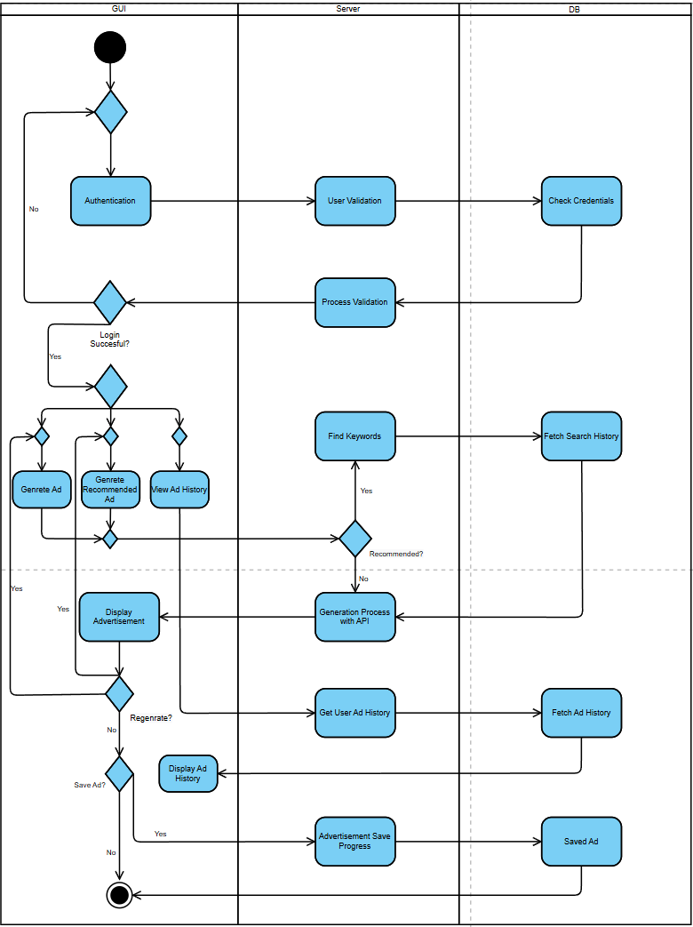

Fig 1 : Activity Diagram

InstaAD Package Diagram:
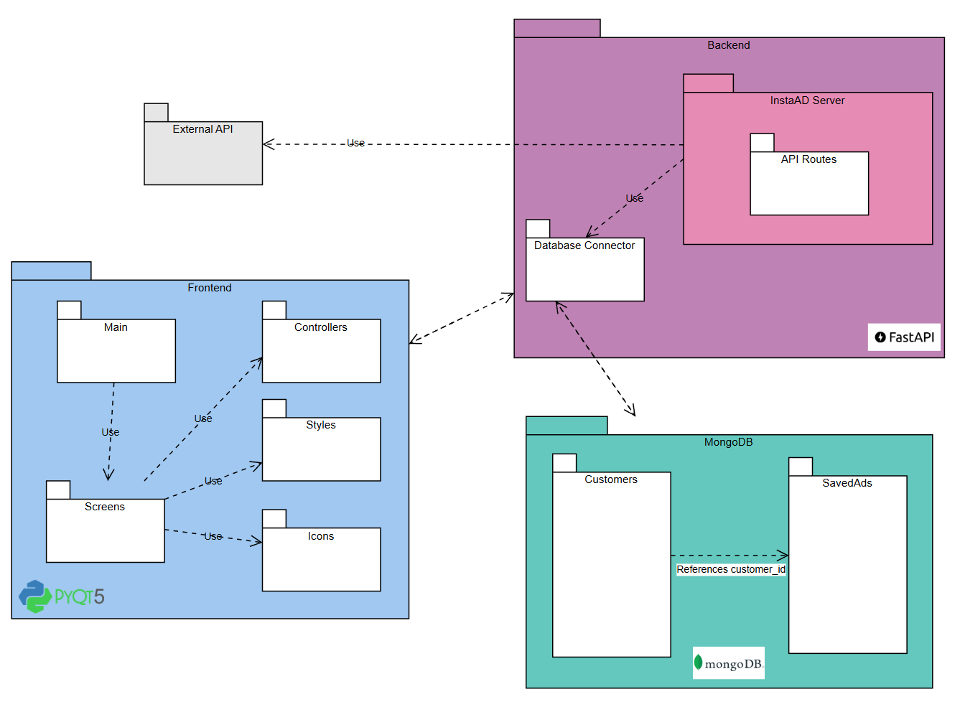

Fig 2 : Package Diagram

5. Testing Plan

A structured and methodical testing process will be conducted to ensure the system functions correctly, performs reliably, and delivers a smooth user experience. Our testing process will include unit testing, integration testing, functional testing, and user interface testing, covering all core components of the application.

5.1 Testing Strategy
We will carry out the following test activities across all layers of the system:

Unit Testing
We will verify all backend logic functions individually using Python's automated testing tools. This includes:
- Validating user input fields for registration and login (e.g., email format, password confirmation, empty fields)
- Verifying correct processing of user prompts
- Ensuring accurate formatting of responses received from AI APIs
- Checking keyword extraction for recommendation logic

Integration Testing
We will test the integration between major system components to confirm seamless data flow and coordination:
- Frontend (PyQt5) will be tested for correct communication with the backend (FastAPI)
- Backend will be tested for successful read/write operations with MongoDB
- Backend will be tested for reliable interaction with third-party APIs (OpenAI and video generation services)
- We will ensure the data structure sent and received in JSON format remains consistent across all interfaces

Functional Testing
We will perform full end-to-end scenario tests, including:
- Registering a new user and confirming their data is saved correctly in MongoDB
- Logging in with correct and incorrect credentials and verifying expected system behavior
- Submitting a prompt and ensuring the full advertisement (text + image/video) is generated, returned, and displayed correctly
- Saving generated ads and verifying their presence in the user’s ad history
- Generating a recommended ad based on prompt history and validating the logic behind keyword-based suggestions

User Interface Testing
We will manually test the graphical user interface to ensure:
- Consistent screen layouts and correct element positioning across screens
- Smooth navigation between screens with no freezes or crashes
- Proper handling and display of error messages (e.g., invalid input or connection failure)
- Real-time user feedback, such as loading indicators during ad generation
- Display of generated content in a user-friendly and readable format

Edge Case and Error Handling Testing
We will test how the system responds to uncommon or problematic scenarios:
- Submitting empty, excessively long, or unsupported language prompts
- Handling slow or failed API responses gracefully without crashing the app
- Attempting multiple incorrect login attempts and ensuring proper feedback is provided
- Generating ads with missing inputs or while disconnected from the internet, and verifying that the system handles these cases with user notifications

5.2 Assumptions and Constraints
The following assumptions and constraints are acknowledged in our testing approach:
- All tests assume stable internet connectivity during interactions with external APIs.
- We assume the third-party services (OpenAI, video generation API) are operational and responsive during testing periods.
- Testing will be limited by API rate limits and usage quotas, which may restrict the number of real-time ad generations during test runs.
- Video generation outputs may require manual verification due to the visual and audio components involved.
- Tests will be conducted on Windows-based environments only; cross-platform testing is not planned in this phase.

5.3 Testing Environment
All testing will be performed in the following environment:
Operating System:
Windows 10/11
Development Tools:
- Python 3.10+
- PyQt5 for GUI
- FastAPI for backend logic
- MongoDB Atlas (cloud database)
- Postman for API endpoint validation
- Visual Studio Code and/or PyCharm for code development and debugging
Test Infrastructure:
- A set of dedicated test user accounts in MongoDB
- A curated list of prompts across various domains (e.g., food, tech, retail) for systematic input testing
- A collection of branded avatar images for use in video synthesis tests

Test results will be recorded, and issues will be logged and resolved before final delivery and presentation. Each core feature will be marked as passed only after both logic and user experience aspects have been verified.

6.Use of AI Tools

In this project, we mostly used Google Scholar search engine for our research, but we also used ChatGPT, an AI tool from OpenAI, to assist with research architecture, specifically for defining the structure and machine learning models that best suit the goals of the project.

1. Prompt:
"What are the current AI-based approaches used for automated advertisement generation, and how do they compare in terms of personalization, flexibility, and scalability?"
Purpose:
To review the main techniques and tools in AI-driven ad generation (e.g., LLMs, GANs, template-based systems), and assess their suitability for personalized content creation at scale.
2. Prompt:
"What are the key considerations when designing the architecture of an AI-powered advertisement generation system for non-technical users?"
Purpose:
To explore the foundational aspects needed for designing a robust, user-friendly system architecture—covering frontend/backend separation, modular API integration, database design, and support for natural language input.
3. Prompt:
"What approaches have been proposed to recommend creative content or ad ideas based on user preferences or history?"
Purpose:
To review techniques such as content-based filtering, collaborative filtering, or embedding similarity for generating personalized creative suggestions in marketing.
4. Prompt:
"Which performance and UX metrics should be used to evaluate an AI-based advertisement generator desktop application?"
Purpose:
To identify appropriate evaluation criteria such as generation time, user satisfaction, API response success rate, and system usability—ensuring the product meets both functional and non-functional goals.
5. Prompt:
"What are the limitations of existing advertisement generation platforms for small businesses and non-technical users?"
Purpose:
To identify gaps in accessibility, creative freedom, and user experience in current solutions, highlighting the motivation for developing more intuitive and flexible AI-based tools.

7. Sources:
1. Artificial Intelligence in Advertising: Advancements, Challenges, and Ethical Considerations in Targeting, Personalization, Content Creation, and Ad Optimization Gao, B., & Huang, Y. (2023):
https://journals.sagepub.com/doi/full/10.1177/21582440231210759
2. Artificial intelligence (AI) applications for marketing: A literature-based study Haleem, Abid, Javaid, Mohd, Qadri, Mohd Asim, Singh, Ravi Pratap, & Suman, Rajiv. (2022):
https://www.sciencedirect.com/science/article/pii/S2666603022000136
3. AI advertising: An overview and guidelines Ford, John, Jain, Varsha, Wadhwani, Ketan, & Gupta, Damini Goyal. (2023):
https://www.sciencedirect.com/science/article/abs/pii/S0148296323004836?via%3Dihub
4. A Comprehensive Survey on Ai Content Generator Jacob, P. P., Jacob, Premy P., Aryalekshmi, A. J., Vimal, Arathi, Arun, A., & Krishnan, Arya G. (2024):
https://www.researchgate.net/publication/386443043_A_Comprehensive_Survey_on_AiContent_Generator
5. Exploring the generative ai for small business: a design thinking approach Aggarwal, Vani, Kaur, Manpreet, Padmaja, Parvathy, & Ahmad, Faraz. (2025)
https://www.abacademies.org/articles/exploring-the-generative-ai-for-small-business-a-design-thinking-approach-17204.html
6. Generative Adversarial Networks for Image and Video Synthesis Liu, Ming-Yu, Huang, Xun, Yu, Jiahui, Wang, Ting-Chun, & Mallya, Arun. (2020):
https://arxiv.org/abs/2008.02793
7. Natural Language Generation for Advertising: A Survey Murakami, Soichiro, Hoshino, Sho Hoshino, & Peinan Zhang (2023):
https://arxiv.org/abs/2306.12719
8. The potential of generative AI for personalized persuasion at scale” Matz, Sandra C., Teeny, Jacob D., Vaid, Sumer S., Peters, Heinrich, Harari, Gali M., & Cerf, Moran. (2024):
https://www.nature.com/articles/s41598-024-53755-0

